Working the Community
Students visited to Sugar Factory on 7th February 2015. Students observed all the processes of the preparation of the sugar and it’s by products and later they submitted the report of the visit.

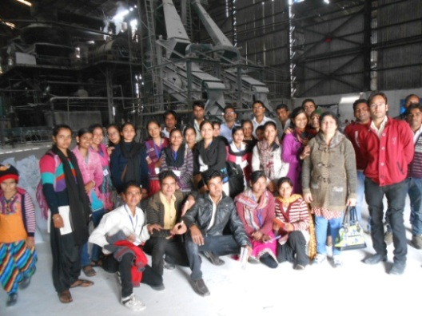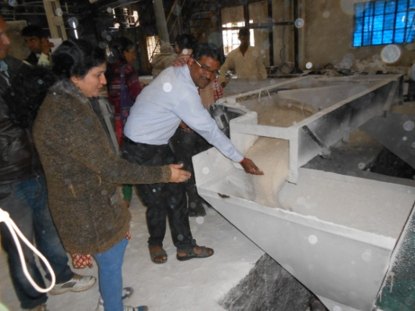
Students and staff of HITT participated in Working with community programme on 19th February 2015. All the students were visited Barsat village near Raghogarh and organized various activities with the school students, teachers and villagers.
